

- Student name: omar Abuhassan
- Student number:22110264
- Major: Data science and artificial intelligence
- Academic year: second
- Subject Tutor: Eng. Razan Al-Quran

Task 1 - Logical Level
1) Create a design for the valid operations that can be performed on different structures; outline the functionalities and the interactions withing the system
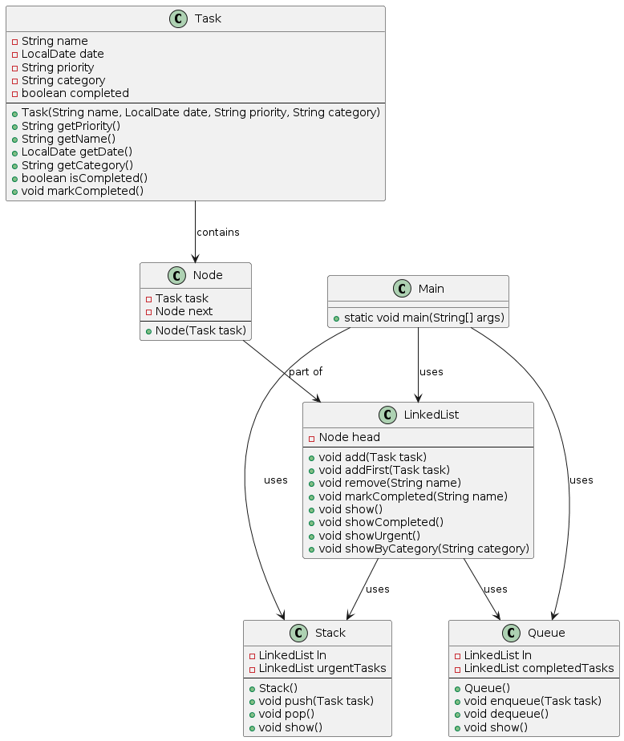

2) Specify the meaning and components of a software stack data type in the conceptual structure.
Introduction:
A stack is a way of organizing data where what goes in In the first comes out last(FILO) and what goes in at the last is what comes out at first and this is what makes it useful in the data structure
Properties and components :
The first in comes out last
Top : indicates the last added element
Bottom: indicates the first item added and stays in the stack until the end
The most important operations:
Push: adds items to the top of the stack
pop : Removes items from the top of the stack
isEmpty: Checks if the stack is empty
Size: shows the number of items in the stack
Clear: the stack is emptied of any items in it
Advantages and disadvantages :
Simple: easy to handle by matrices and Linked Lists
Memory organization: where it lies in the repetition of calls, which helps in the management and organization of memory
Inverting elements: such as letters and numbers

As for some disadvantages
Difficulty of access : only the last added items can be accessed
An illustrative example with a drawing
Let stack in rank 3 and we want to fill it by number from 0 to 2
Push:
0
Here stack is full
1
2
0
Push(2)
Watch here what entered first stays in its place and what entered after it comes on top of it
1
0
Push(1)
Push
(0)
Here stack is empty

Pop:
Note that the pop is just to the element in the top
Look here the last input is first one out from stack
Look here the 0 is first element but it’s the last element out
Here stack is empty
Pop(0)
0
Pop
(1)
1
0
Pop(2)
1
2
0
Referring to the system description in task1.1 and its structure specifications, examine the advantages of encapsulation and information hiding when using an ADT in the main method. support your answers with examples
One of the most important basic principles in OOP is packaging and hiding information, which is very useful during the implementation of ADT, such as stacks, queues, and linked lists, and it provides many advantages that I will mention later.

1. Encapsulation and its benefits
Encapsulation is the collection of data and functions that operate in a single unit (class) and this leads to the concealment of the internal processes of the object and its functions and does not reveal only what is necessary

Benefits:
Modularity: The code is divided into units by encapsulating data and methods, and this makes the system simple to understand, develop and maintain

Data protection: Encapsulation prevents access to processes that get the object, and this reduces external interference and errors

Flexibility: The actions that get the object during class execution do not affect the code
2. Information Hiding and its benefits
It is one of the principles of design where the user interacts with the program through a simplified interface without the need to know what is behind the interface

Advantages:
Simplicity: Interact with a simple interface that hides all the complexities in the program, and this is what facilitates dealing with the program

Security: It reduces misuse and external interference by hiding implementation details, which maintains the integrity of data and operations
3. Application in the main way
Consider stack, queue, and linked list applications. By encapsulating data structures and processes, the main method can interact with these ADT tools through a simple and clean interface. This encapsulation and concealment ensures that the main method does not need to know the internal details of these structures, making the code more robust and easier to maintain.

Implement the designed solution in task 1 for the presented problem using an executable programming language (Java) including error handling mechanisms. Run a testing of the application (executable main method) and document the outcomes.
1.Task class:
- Make sure the name is correct: If the name is empty, the program will print an error message, which restarts the program, thus preventing the creation of a task without a name
- Priority check: When you enter a value other than ('low', 'medium' or 'urgent'), the program will print an error message and then restart
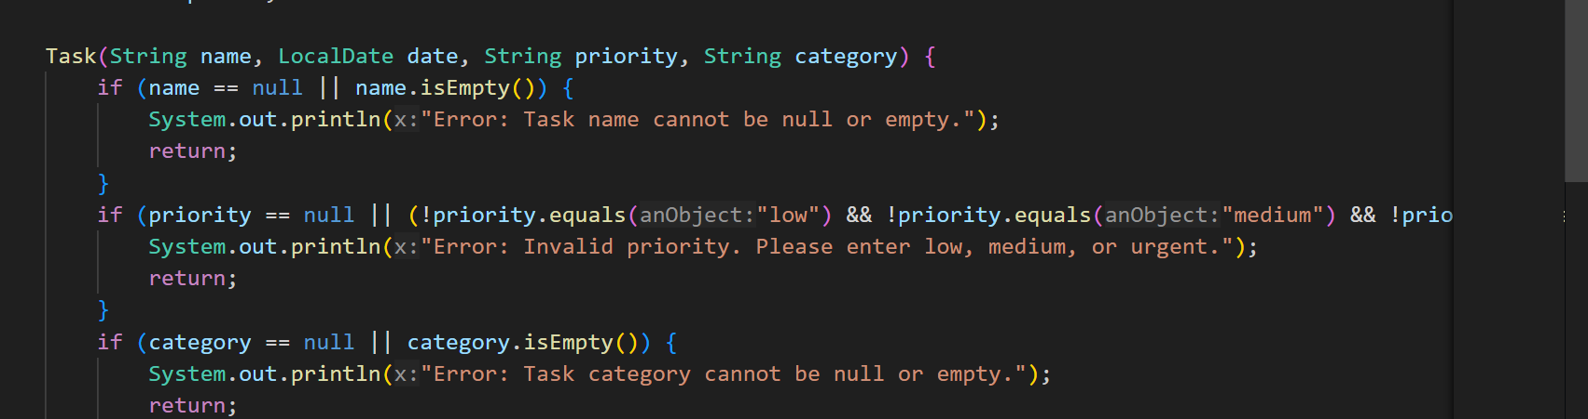
- category check: Makes sure that the task has a class and that the class is not empty, if it is empty, it will print an error message

LinkedList class:
- During the addition:
The task is checked for empty, so if it is, it will print an error message and will not store it
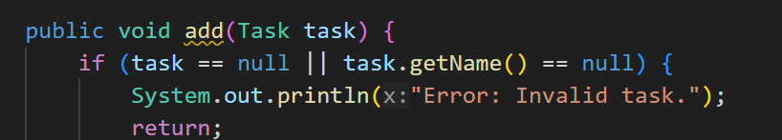
During remove:
- The list is emptied, and if it is, an error message is printed
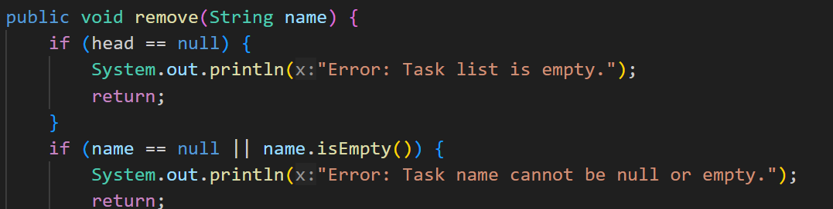
- The name is confirmed, and the task is present
Markcompleted:
- Name verification
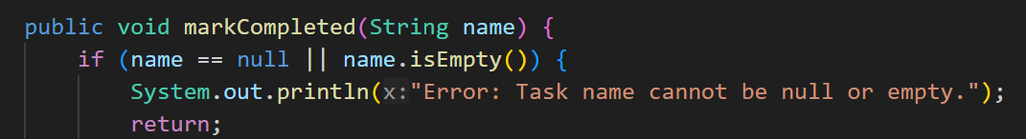
- Check for task existence
show:
- Check that the list is not empty
- The list is checked that the list is not empty
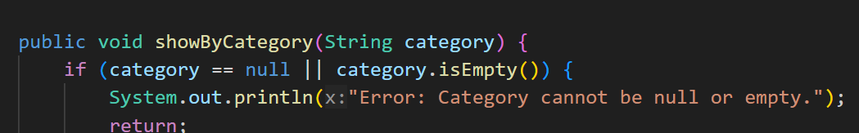
- Make sure the task exists
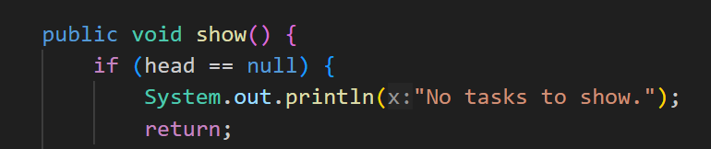
Stack class:
Push:
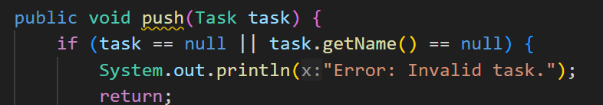
- Validate the task by whether it is empty or unnamed

Pop :
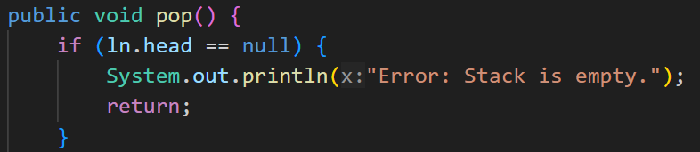
- Verify that the head has value
Queue class:
Enqueue:
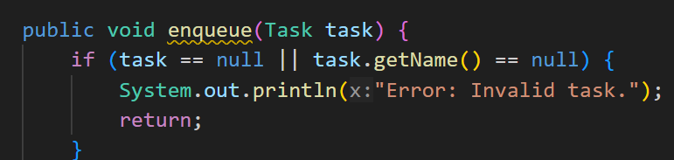
- Validate the task and have a name
Dequeue:
- Check that the head is not empty
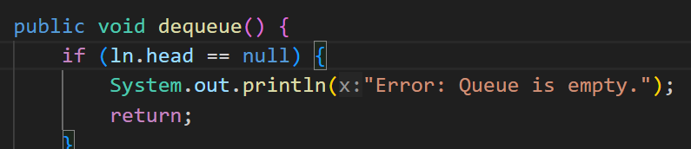

summary
Constructor validation: Ensures tasks are created with valid values for name, priority, and category.
Validate the selected method: Each method in the LinkedList, Stack, and Queue classes contains checks to ensure that the input is correct and that empty structures are handled safely.
Referring to your implementation of FIFO queue, and the test cases in the experiment, provide an illustrate of at least 4 operations of queue data structure
Definition:
The queue is a method of organizing data that works on the principle of first to enter and exit (FIFO), and can be likened to a queue of people waiting for a specific service as the first to stand in line is the first to be provided with the service
Characteristics:
- FIFO: Ensures that items are arranged in the order mentioned earlier
- Enqueue: Adds items to the end of the queue
- Dequeue: Removes items from the beginning of the queue obituary
- Front: First Element
- Rear: The Last Element
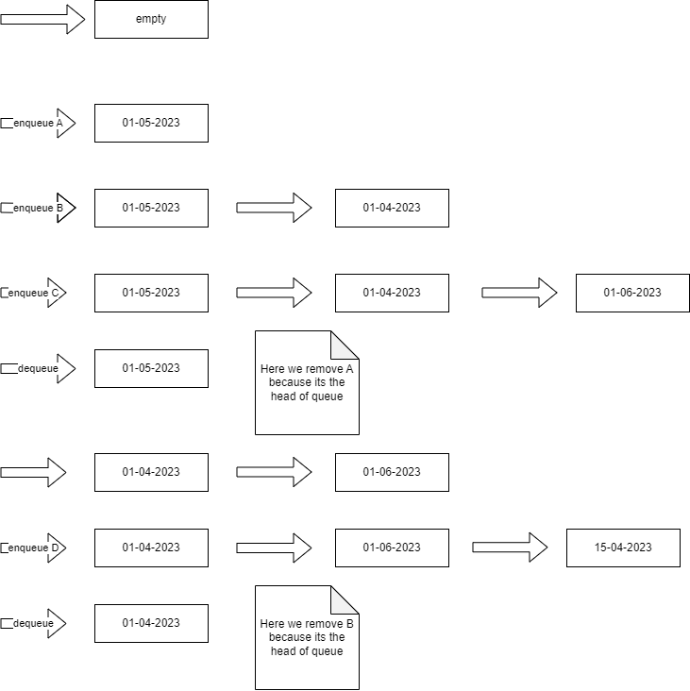

Referring to the scenario and the implemented solution, demonstrate how the ADTs/and Algorithms collaborate to address the problem at hand. How you think that using independent ADTs improves software development over different aspects
A)LinkedList:
- Role:
ADT LinkedList works to store and manage tasks
- Operations:
- Add tasks to the end of the list
- Remove task based on name
- Mark tasks complete
- Show tasks
- Algorithm:
Traversal: The linked list is passed to find the selected task or its end
B)Stack
- Role:
The stack ADT is used to manage urgent tasks, where the closest date is executed first, it can be likened to the pile of dishes, the first dish that was placed is the last to be used.
- Operations:
- Add urgent tasks in order relative to their date
- Remove urgent tasks (from highest to lowest)

- Algorithm:
Ordered Insertion: where tasks are listed in a way that keeps them arranged according to their date
C)Queue:
- Role:
The Queue ADT is used to manage tasks based on the method of what enters first out, which makes the implementation according to the due order

- Operations:
- Add tasks in order of date
Rem Task Addition over tasks based on entitlement
Show completed missions
Algorithm:
Orderly inclusion: works the same way as the stack but it is for non-urgent tasks (according to date)

Collaboration between algorithms and ADT:
1) Task Addition:
When the task is added, it is stored in the LinkedList, if it is urgent, the Stack will be push in the correct order, while for the Queue, it is arranged according to due dates.

2) Task Processing:
Regular tasks are managed through the queue, while the LinkedList provides full management of all tasks

3) Task Completion:
When a task is completed by flagging it, it is updated in the LinkedList, and displayed in completed tasks by the processes in the Queue.
Using standalone ADT tools to manage tasks in your project improves software development by enhancing modularity, reusability, maintainability, scalability, testability, and flexibility. The collaboration between LinkedList, Stack, and Queue ensures that tasks are efficiently handled and organized based on their priority and due dates, and that the issue is effectively addressed.
To implement the necessary functionalities in the task management system, you may opt to utilize existing Abstract Data Types (ADTs) or devise new ones. However, it's crucial to analyze the tradeoffs in terms of time and space complexities when considering ADTs such as Binary Search Trees (BST), Sorted Arrays, and Ordered Linked Lists for operations like search, insert, and remove. Interpret the trade-offs through various implementations, outlining the comparative analysis of each ADT, the impact on the overall performance of the task management system.

Operation | BST | Ordered linked List | Sorted Array
Search | O(log n) | O(n) | O(log n)
Insert | O(log n) | O(n) | O(n)
Remove | O(log n) | O(n) | O(n)
Space com | O(n) | O(n) | O(n)

Detailed comparative analysis
- Binary Search Tree (BST)
- Time complexity:
- Search: O(log n) on average if the tree is balanced. In the worst case (unbalanced tree), it can decompose into O(n).
- insert : O(log n) on average for a balanced tree. As with research, it can deteriorate into O(n) in the worst case.
- Remove: O(log n) on average for a balanced tree. The worst case is O(n).
- Space complexity:
- Space: O(n) where each node requires additional space for cursors (left and right children).
- Advantages:
- Effective search, insert, and removal processes when balanced.
- Dynamically adapts to insertions and deletions, maintaining balance with technologies such as AVL or Red-Black Trees.

- Disadvantage:
- The complexity increases if the tree becomes unbalanced.
- More complex in implementation and maintenance due to balancing operations.
- Ordered linked list
- Time complexity:
- Search: O(n) because it requires traversing the list to find an item.
- Insert : O(n) because the correct position must be found by traversing the list.
- Remove: O(n) because it requires finding the item to be removed.
- Space complexity:
- Space: O(n) with additional space for the next cursor in each node.
- Advantages:
- Simple to implement.
- Insertion maintains order, making it easy to keep tasks sorted.
- Disadvantage:
- Inefficient for large datasets due to the linear time complexity of searching, inserting, and removal.
- Not suitable for repetitive or critical operations of performance.

- Ordered matrix
- Time complexity:
- Search: O(log n) using binary search.
- insert: O(n) because the items need to be moved to maintain order.
- Remove: O(n) where items must be shifted after removal.
- Space complexity:
- Space : O(n) but resizing the array (if implemented) can lead to additional complexity.
- Advantages:
- Fast searches due to binary search.
- Easy to implement with predictable performance.
- Disadvantage:
- Inefficient insertion and removal operations due to changing items.
- Fixed size unless resized dynamically, adding complexity and potential load.
- Impact on the task management system
When integrating these tools into a task management system, the choice depends on the specific requirements and constraints:

- Binary Search Tree (BST)
- Use case: Suitable for a balanced mix of searches, inserts and removals. Ideal for dynamic datasets where tasks are frequently added and removed.
- Performance: Provides balanced performance but requires additional logic to maintain balance.
- Ordered linked list
- Use case: Suitable for simpler applications with small datasets or when operations are not necessary for performance.
- Performance: It suffers from linear time complexity, making it less suitable for large datasets or repetitive operations.
- Ordered matrix
- Use case: Ideal for applications where quick searches are critical and insert/removal operations are rare.
- Performance: Provides a quick but inefficient search for repeated insertions and deletions.

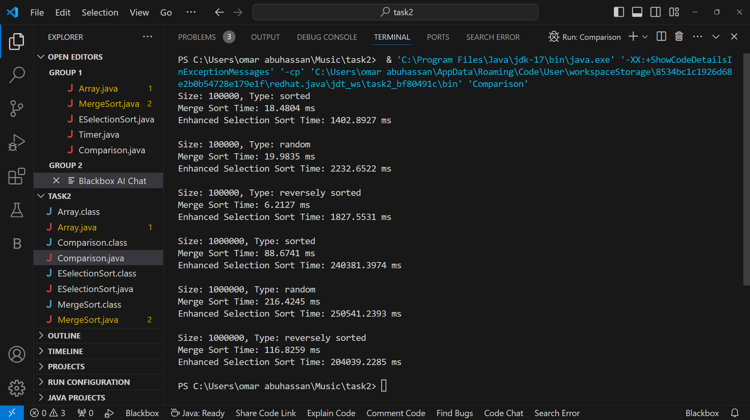
Visualize the results in chart (size vs time) then Conclude insights and discuss the findings in the light of each algorithm complexity and different array sizes and types, Calculate/predict the time required by each algorithm to sort 1010 input, given a CPU that executes an operation in 10-10 seconds.
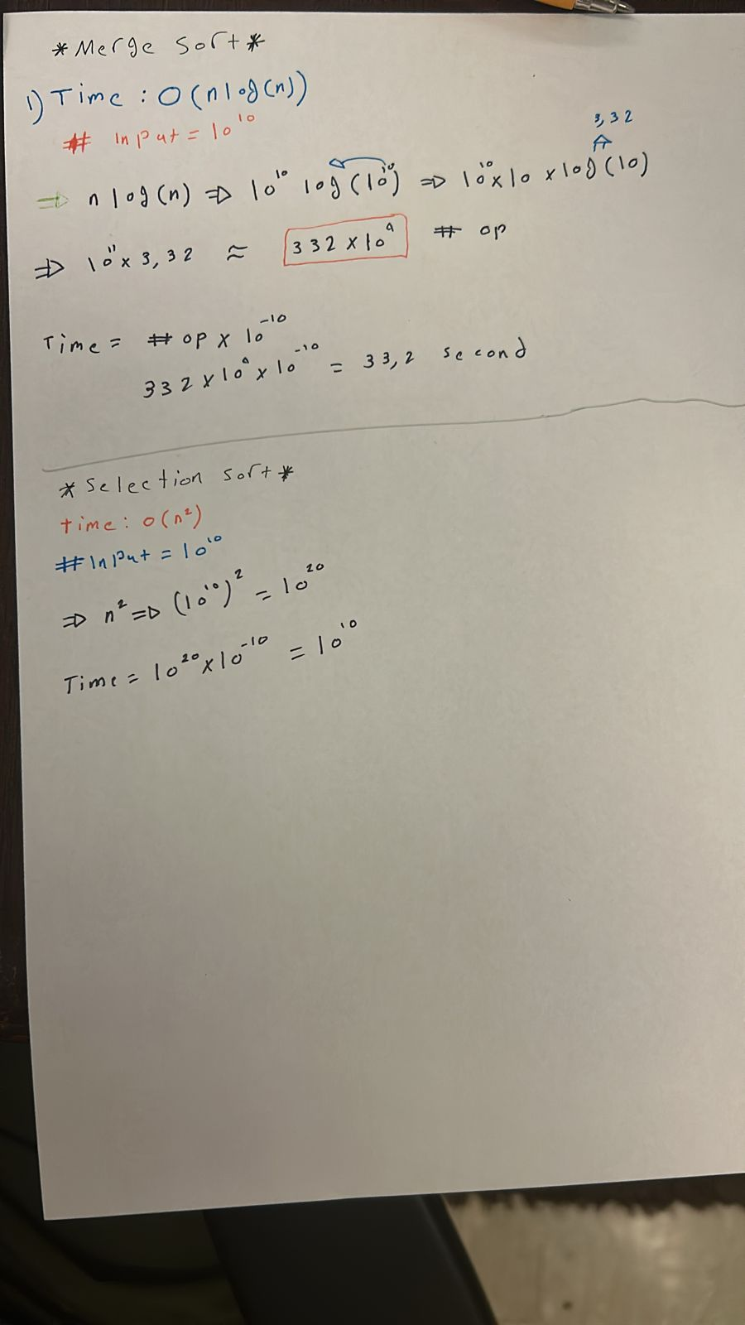

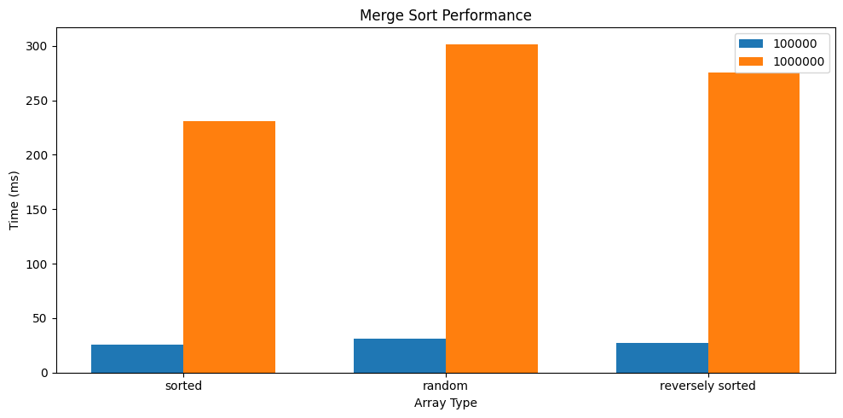
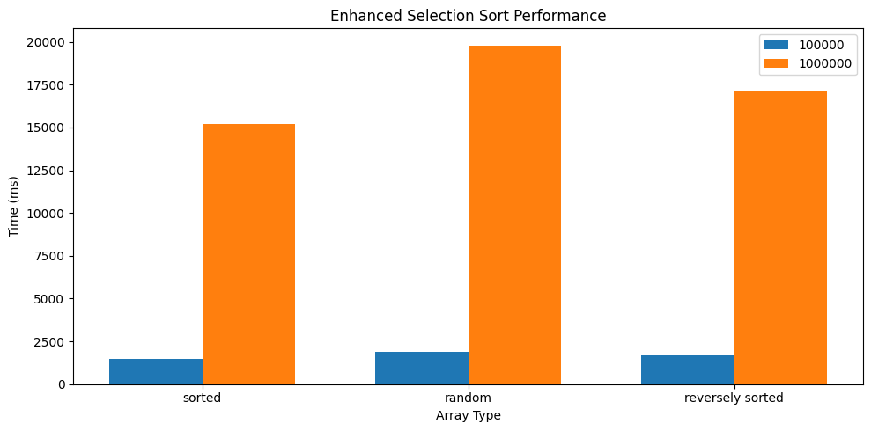
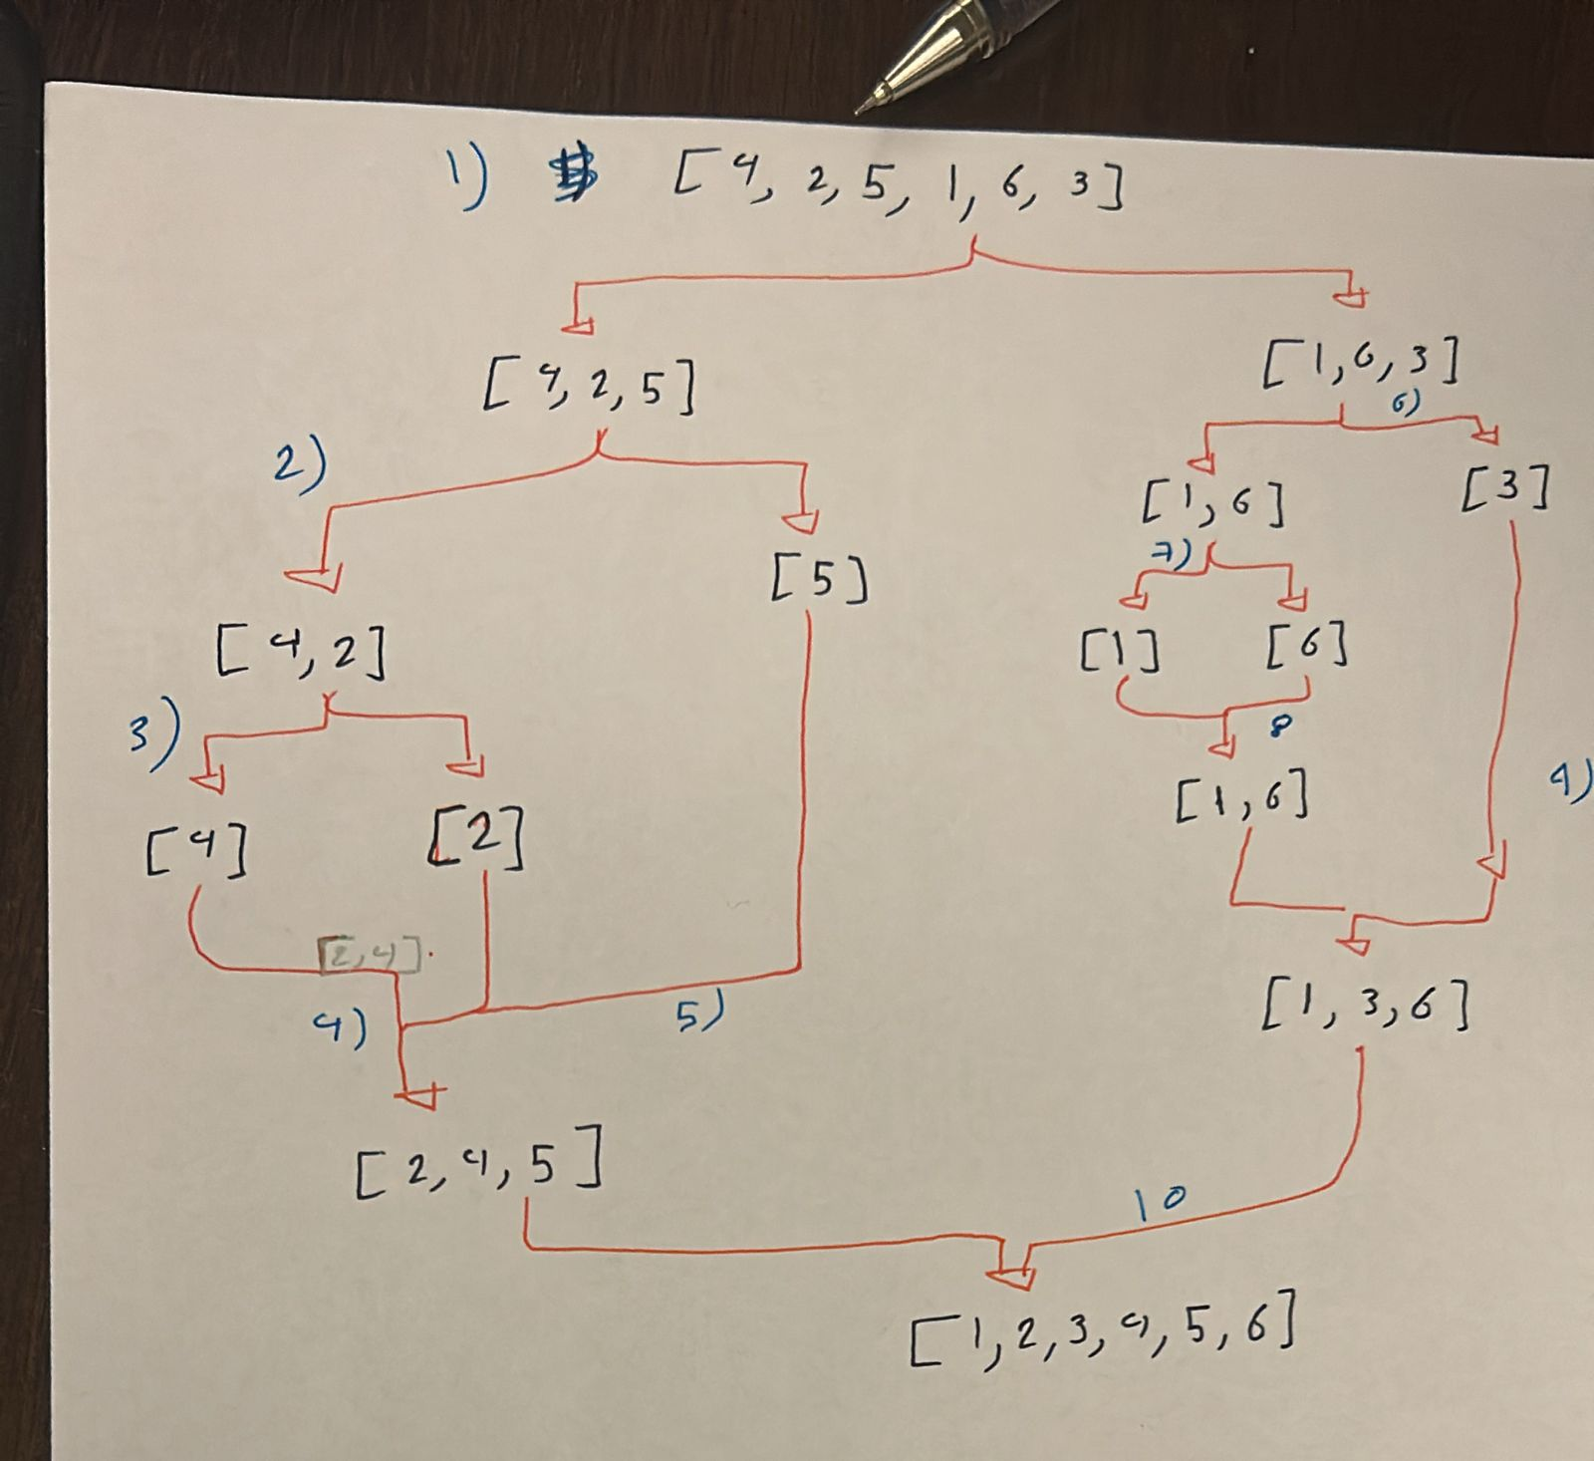
Considering the recursive implementation of Merge Sort algorithm in the previous step, Determine how the memory stack frames are used when invoking the recursive function with an array of size 6 filled randomly. Determine the operations performed by a memory stack in detail

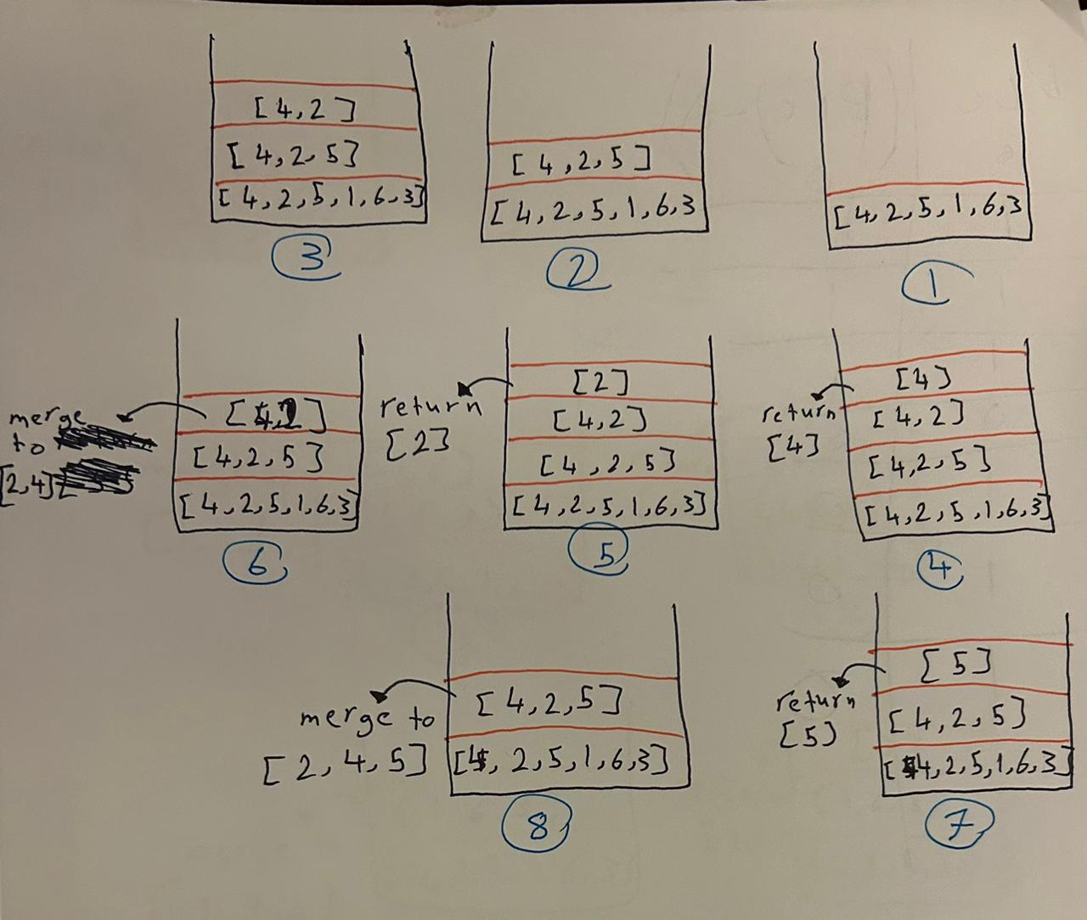

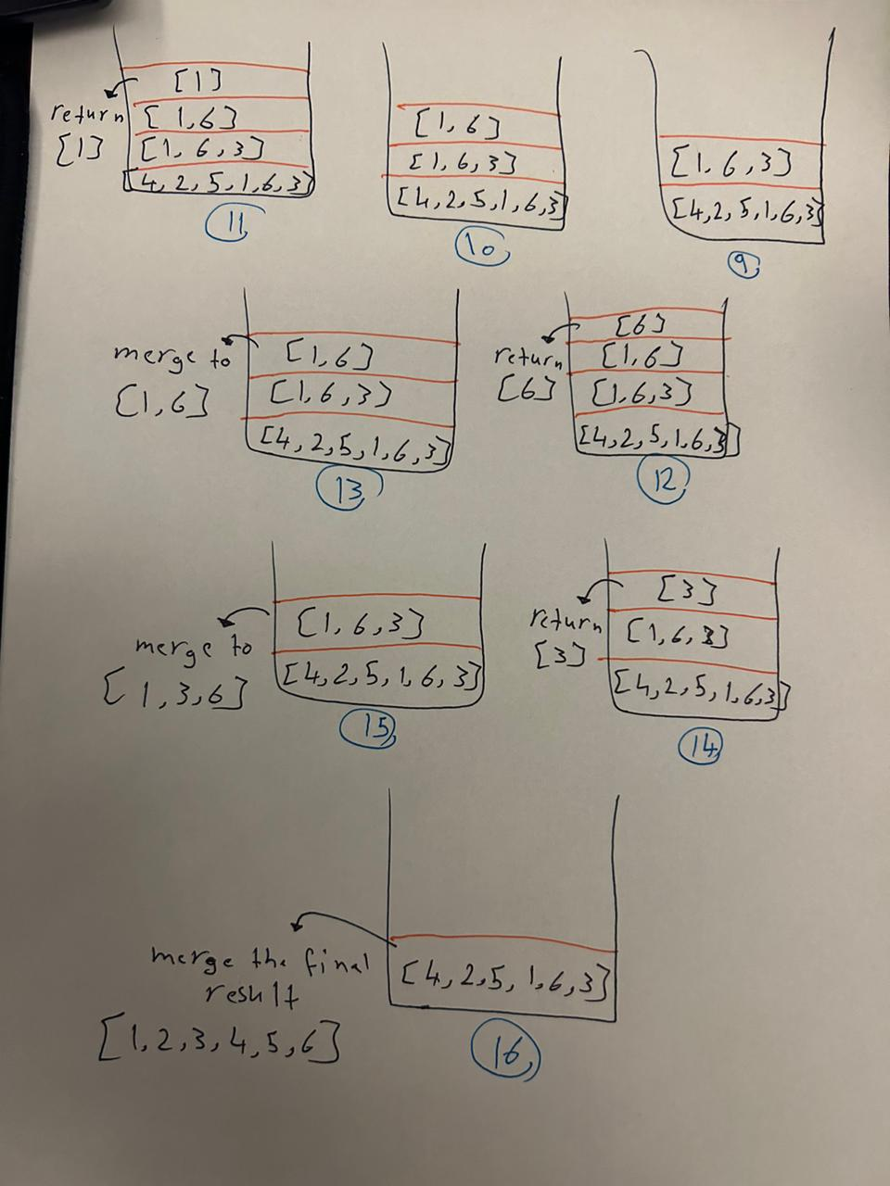
Criteria | Enhanced Selection Sort | Merge Sort
Time Complexity
- Best Case | O(n^2) | O(nlogn)
- Average Case | O(n^2) | O(nlogn)
- Worst Case | O(n^2) | O(nlogn)
Space Complexity | O(1) (in-place sorting) | O(n) (due to temporary arrays)
Efficiency | Less efficient for large datasets | More efficient for large datasets
Use Case | Small datasets or memory-constrained environments | Large datasets, general-purpose sorting

Discuss how Big-O notation can be used to assess the efficiency of an algorithm. What is the asymptotic analysis of the two sorting algorithms implemented in the previous task. Compare the efficiency of both sorting algorithms based on this analysis.

In the above task, you have conducted the experimental method of measuring the performance of an algorithm, determine two alternative methods can be used measure efficiency, illustrate your answer with an example
Theoretical analysis
It is also known as asymptotic analysis based mainly on the analysis of the time complexity and space complexity of the algorithm through the use of some mathematical equations, and through this it provides a high level of understanding of the performance of the algorithm by focusing on the growth rate of the operating time or space requirements for increasing the input size
Example: Consider Merge Sort and Bubble Sort:
- Merge Sort:
  - Time Complexity: O(nlogn)
  - Space Complexity: O(n)
By splitting the array and merging, Merge Sort divides the problem into smaller subproblems, each taking linear time across logarithmic levels of recursion.
- Bubble Sort:
  - Time Complexity: (n^2)
  - Space Complexity: O(1)
Bubble Sort repeatedly swaps adjacent elements if they are in the wrong order, leading to a quadratic number of comparisons and swaps.
Illustration: For an input size of n=1000:
- Merge Sort would perform approximately 1000×log2(1000)≈1000×10=10000 operations.
- Bubble Sort would perform approximately
- 1000^2 = 1000000 operations.
Theoretical analysis shows that Merge Sort scales much better with increasing input size compared to Bubble Sort.

Standard profiling
It works on the use of special tools to analyze the behavior of the algorithm's runtime, identify bottlenecks, and measure the actual use of time and space during the implementation process
Example: Consider an implementation of Quick Sort and Insertion Sort:
- Quick Sort:
  - Profiling might reveal the distribution of time spent in partitioning and recursive calls.
  - Benchmarking would involve running Quick Sort on various datasets (sorted, reverse sorted, random) and recording execution times.
- Insertion Sort:
  - Profiling would show time spent on element comparisons and shifts.
  - Benchmarking would involve running Insertion Sort on the same datasets and comparing execution times to Quick Sort.
Illustration: Using a profiling tool like gprof or a benchmarking framework like Google Benchmark, you might observe the following:
- For an input of size n=1000:
  - Quick Sort takes 5ms on average with random data.
  - Insertion Sort takes 50ms on average with random data.
- Profiling Quick Sort shows most time spent in recursive calls and partitioning, while Insertion Sort spends most time in the inner loop for comparisons and shifts.

